UNIVERSITY OF WAH (UOW)

DEPARTMENT OF COMPUTER SCIENCE



BSCS 3RD B

REG #: UW-24-CS-BS-088

SUBMITTED BY: SAADI SAFDAR

SUBMITTED TO: SIR. HASSAN SHAFAQAT

COURSE TITLE: COMPUTER NETWORKS

COURSE CODE: CS – 241 L

FINAL LAB SESSIONAL

Q1. A family home has multiple smartphones and laptops that need secure wireless
access while a desktop computer is connected via cable; DESIGN a wireless network
using 2 wireless router, 3 wireless devices, and 1 wired PC, configure wireless
security and IP addressing, and confirm that all devices can communicate successfully
within the network.

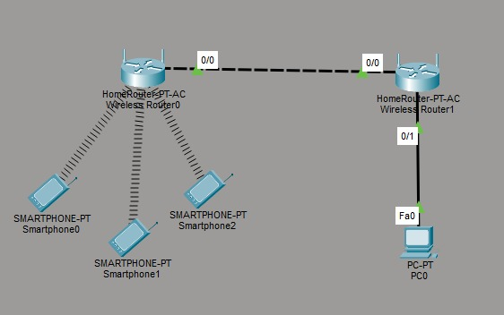
R1:
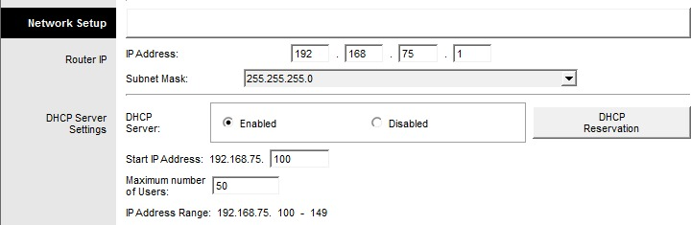
R2:
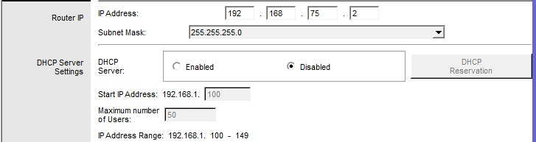
PC:
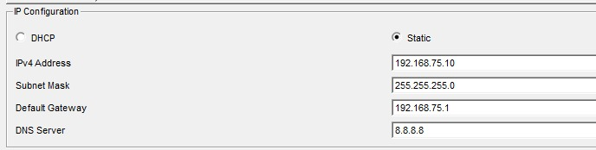
Q2: A multinational company connects its headquarters network to a partner
organization’s network, where both use separate routing domains; APPLY BGP
dynamic routing by designing a topology with 4 routers (2 per Autonomous System),
2 switches, and 2 PCs, configure eBGP between the AS networks, and verify that
routes are exchanged correctly.

Topology:
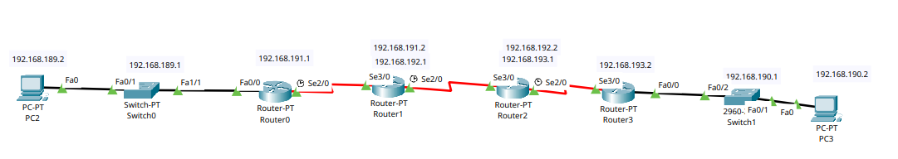
IP Addressing:

Device | Interface | IP Address | Subnet Mask | Default Gateway
PC2 | Fa0 | 192.168.189.2 | 255.255.255.0 | 192.168.189.1
Router0 | Fa0/0 | 192.168.189.1 | 255.255.255.0 | N/A
Router0 | Se2/0 | 192.168.191.1 | 255.255.255.0 | N/A
Router1 | Se3/0 | 192.168.191.2 | 255.255.255.0 | N/A
Router1 | Se2/0 | 192.168.192.1 | 255.255.255.0 | N/A
Router2 | Se3/0 | 192.168.192.2 | 255.255.255.0 | N/A
Router2 | Se2/0 | 192.168.193.1 | 255.255.255.0 | N/A
Router3 | Se3/0 | 192.168.193.2 | 255.255.255.0 | N/A
Router3 | Fa0/0 | 192.168.190.1 | 255.255.255.0 | N/A
PC3 | Fa0 | 192.168.190.2 | 255.255.255.0 | 192.168.190.1

CLI for routers:
Router 0
Bash
en
conf t
ip route 0.0.0.0 0.0.0.0 192.168.191.2

Router 1
Bash
en
conf t
ip route 192.168.189.0 255.255.255.0 192.168.191.1
router bgp 100
neighbor 192.168.192.2 remote-as 200
network 192.168.189.0 mask 255.255.255.0
network 192.168.191.0 mask 255.255.255.0

Router 2
Bash
en
conf t
ip route 192.168.190.0 255.255.255.0 192.168.193.2
router bgp 200
neighbor 192.168.192.1 remote-as 100
network 192.168.190.0 mask 255.255.255.0
network 192.168.193.0 mask 255.255.255.0

Router 3
Bash
en
conf t
ip route 0.0.0.0 0.0.0.0 192.168.193.1

Results:

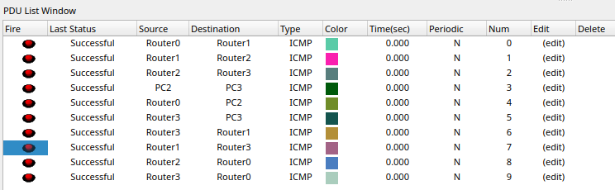
Q3: A logistics company has three warehouses connected through routers and needs
fast route convergence to avoid delivery delays; ANALYZE the network and
configure EIGRP using 3 routers, 3 switches, and 3 PCs, ensure all routers use the
same EIGRP autonomous system number, disable auto-summary, and verify end-to-
end connectivity.

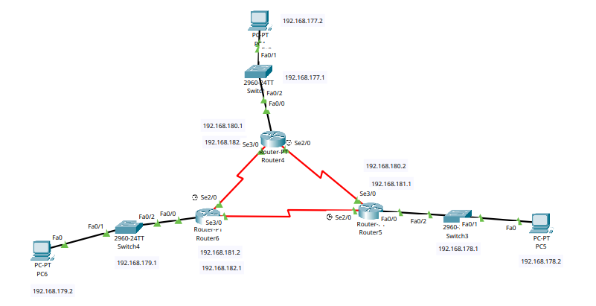

IP Addressing:
Device | Interface | IP Address | Subnet Mask
PC2 | Fa0 | 192.168.189.2 | 255.255.255.0
Router0 | Fa0/0 | 192.168.189.1 | 255.255.255.0
Router0 | Se2/0 | 192.168.191.1 | 255.255.255.0
Router1 | Se3/0 | 192.168.191.2 | 255.255.255.0
Router1 | Se2/0 | 192.168.192.1 | 255.255.255.0
Router2 | Se3/0 | 192.168.192.2 | 255.255.255.0
Router2 | Se2/0 | 192.168.193.1 | 255.255.255.0
Router3 | Se3/0 | 192.168.193.2 | 255.255.255.0
Router3 | Fa0/0 | 192.168.190.1 | 255.255.255.0
PC3 | Fa0 | 192.168.190.2 | 255.255.255.0

CLI for routers:
On Router 4:
Bash
en
conf t
router eigrp 88
no auto-summary
network 192.168.177.0
network 192.168.180.0
network 192.168.182.0
On Router 5:
Bash
en
conf t
router eigrp 88
no auto-summary
network 192.168.178.0
network 192.168.180.0
network 192.168.181.0
On Router 6:
Bash
en
conf t
router eigrp 88
no auto-summary
network 192.168.179.0
network 192.168.181.0
network 192.168.182.0

Results:

